St. Winifred’s R.C. Primary School,
a Voluntary Academy



CARITAS – God’s love in action

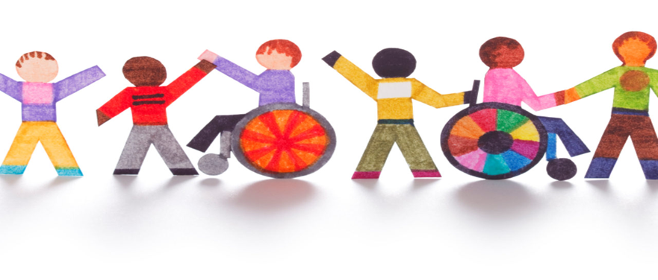

Our Anti-Racism Policy to help children

Anti-Racism Policy


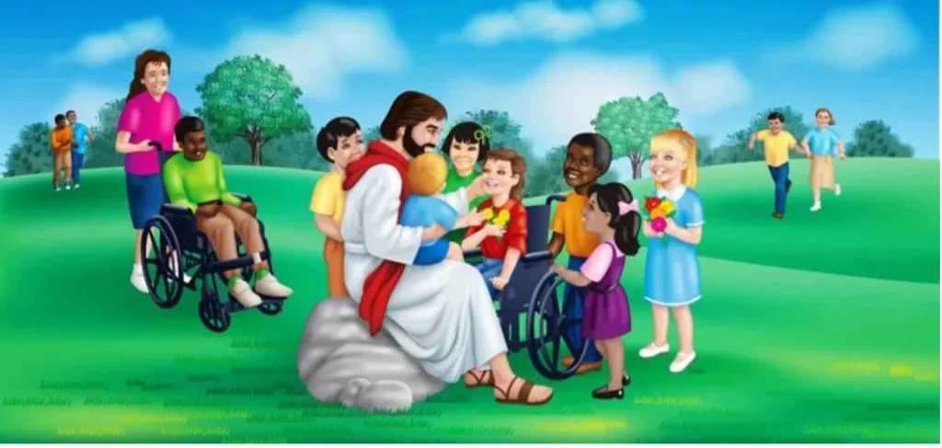
Our Mission Statement

At St. Winifred’s, as a Catholic school, our purpose is to ensure that all members of our school family live our school motto of CARITAS – God’s love in action. This is shown through our love of God, our love of ourselves, our love of each other and our love of the world.

Everyone in our school wants to keep all children safe. We think this policy helps everyone to do this.

At St Winifred’s, we believe that God made every person special, and we must show CARITAS – God’s love in action. This means:
- We love God
- We love ourselves
- We love each other
- We love the world
Because of this, racism has no place in our school.
What is racism?
Racism is when someone is unkind, unfair or hurtful to another person because of:
- their skin colour
- their race or ethnicity
- where they or their family come from
- their culture, heritage or language
Racism can happen once or many times, and it can make people feel sad, scared or left out.

Racism is always wrong because everyone is made in the image and likeness of God.

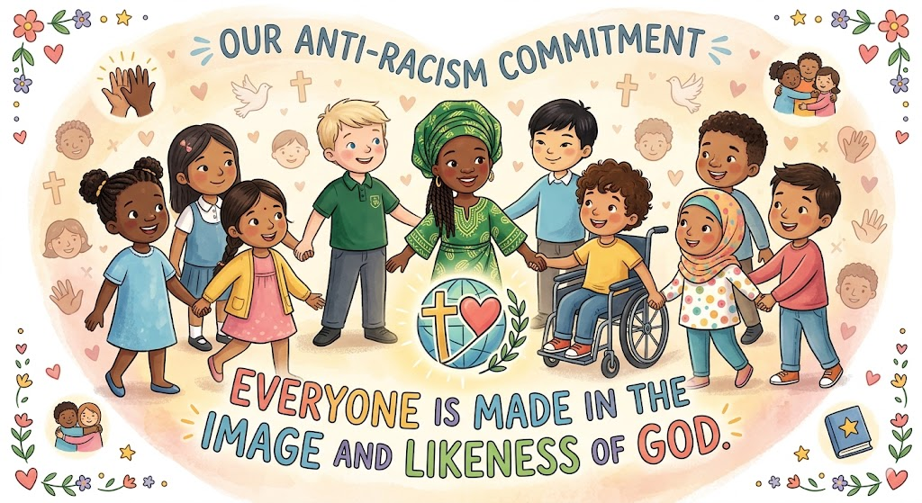

What does racism look like?
Here are some examples:
- Calling someone names about their skin colour or where they come from
- Making fun of someone’s accent or language
- Leaving someone out because of their race
- Spreading unkind stories about someone’s culture
- Using racist words, gestures or emojis
- Making comments about someone’s hair, food or clothes in a hurtful way
- Saying someone “doesn’t belong”

If you’re not sure whether something is racist, ask a trusted adult. If it hurts someone because of who they are, it must be taken seriously.



What should I do if someone is racist to me?
START TELLING OTHER PEOPLE (this will help it to STOP)

DO | DON’T
- Use eye contact and tell them to stop  - Ignore them  - Walk away  - Remember, it is NOT your fault!  - Act as though you don’t care what they say or do, “sticks and stones will break my bones…”  - Report the bullying using our helping hand framework | - Do what they say  • Look upset or cry  • Get angry  • Hit them back

Use your helping hand to tell someone you trust

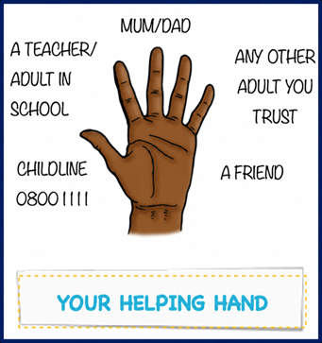

Tell:
- your teacher
- a Teaching Assistant,
- a lunchtime supervisor,
- a trusted adult at home
- a friend who can help you tell an adult
What should I do if I see racism happening?

You can help by:
- Telling the person to STOP if it is safe
- Getting an adult straight away
- Sitting with or supporting the person who was hurt
- Not joining in
- Not laughing or sharing racist comments
- Speaking up, even if it’s hard
- Be an ‘upstander’ not a ‘bystander’
Being a bystander who stays silent can make the problem worse. Being an upstander helps keep our school safe.
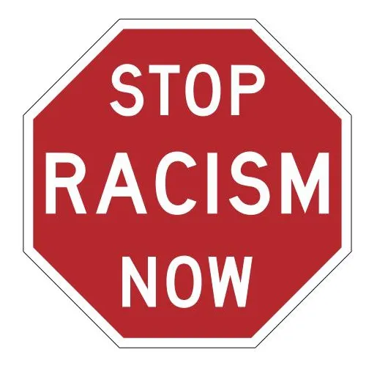

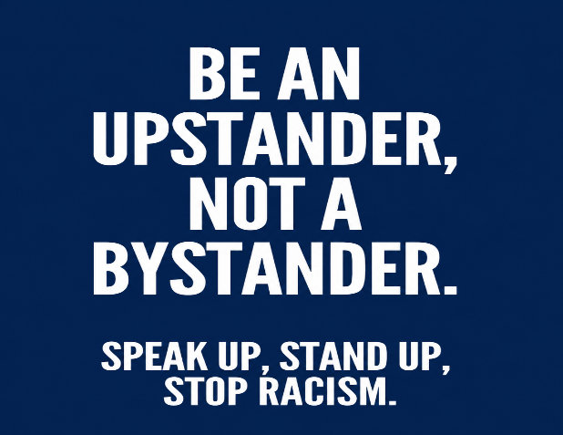

What will our school do to STOP racism?
Our school will:
- Listen carefully to anyone who reports racism
- Take every incident seriously
- Record what happened on CPOMS
- Speak to everyone involved
- Help children understand why racism is wrong
- Support the child who was hurt
- Help the child who caused harm to make better choices
- Talk to parents when needed
- Make sure the racism stops for good

We will also learn about respect, kindness, equality, and diversity in our lessons, assemblies and circle times.
How does our faith help us?
Jesus teaches us to:
- love one another
- treat everyone with dignity
- stand up for what is right
- welcome everyone as part of God’s family

Racism goes against everything Jesus taught. At St Winifred’s, we promise to show CARITAS by treating everyone with love and respect.

Reviewing our policy
This child friendly Anti-racism policy will be reviewed by pupil leaders during Anti-bullying week and then presented to all children, staff and parents every year.



