 | BUZZ ABOUT BOOKS  Promoting Reading for Pleasure at St Winifred’s  Spring 2024

Dear Children and Families,

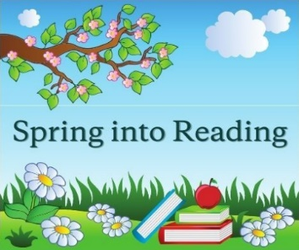
World Book Day 2024, held on Thursday 7th March, got our new season of reading off to a brilliant start! It was a fantastic day, led by our old friends Horrid Henry and Perfect Peter. Your costumes were amazing – as always – and every class had a really memorable day of fun activities dedicated to the joy of reading.
Have you spent your £1 voucher yet?
In addition, the Family and Friends of St Winifred’s organisation generously donated an additional £5 voucher to each class to spend on a book of their choice and some of the lucky winners were Daniel in Class 6, Harry in Class 9 and Ava in Class 13.
In the run-up to World Book Day we held an ‘Extreme Reading’ event where lots of you sent in gorgeous photographs of yourselves – and some adorable pets - reading in unusual ways or places. Huge thanks to all of you who joined in! We made a short video of all your entries and you can view it on the school website, under Pupil Area -> Reading for Pleasure -> Our Book Enthusiasts.
Do keep an eye on the Reading for Pleasure area of the website, as Mrs Haynes and Ms Harrison are updating it with useful information on a regular basis. For example, you might like to see how many of the "Ten must-reads" you have read from the Words for Life website, run by the National Literacy Trust.
Please let Ms Harrison or any of the Reading Ambassadors know if you have any great ideas of items to include on the website!
Meet (the rest of) the Year 5 Reading Ambassadors
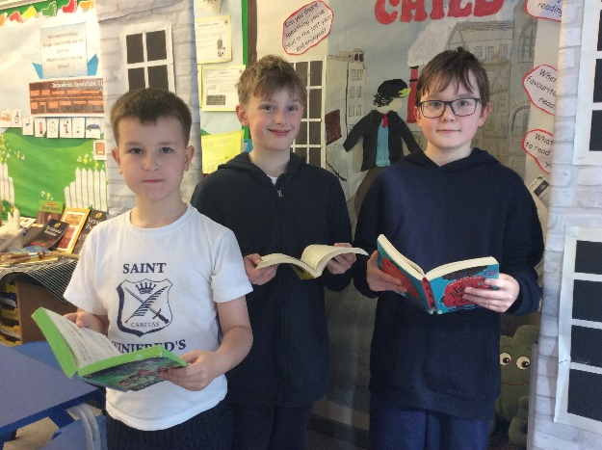
Lucas, Matthew and Theo weren’t available when I interviewed the Year 5 Reading Ambassadors for the Autumn/Winter newsletter but I have caught up with them now! These fine young men love to read football books – both fiction and biographies – and adventure stories. Theo says “Reading opens up new adventures – it’s like a holiday in my mind”. Matthew quoted the Jane Austen character who said, “I declare after all there is no enjoyment like reading!" - this quotation can be found on a £10 note (though it is a little controversial!)
Our fabulous Reading Ambassadors undertake various tasks to help to promote Reading for Pleasure throughout the school, including keeping the School Library tidy, which improves it greatly for the whole school community.
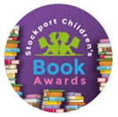
Stockport Children’s Book Awards
Have you heard of the Stockport Children's Book Awards? It started in 1996 and lots of Stockport Primary schools take part. It's run every year by Stockport Libraries, and they shortlist three new books for each of:
- Key Stage 1 - Reception, Year 1 and Year 2
- Lower Key Stage 2 – Year 3 and Year 4
- Upper Key Stage 2 – Year 5 and Year 6.

It is unique, because it is the only children’s book award where children decide the winner.
In Key Stage 1, the class teachers read each book to their class and the children vote for their favourite. In Key Stage 2, the class teachers read the blurb and the first few chapters of each book to their class, and the class votes to see which book they would like to hear the rest of. This will then become the class novel. Votes from all the classes are added up and sent to the organisers by May half-term.
This year’s shortlisted books are:
KS1: | Mavis the Bravest, by Lu Fraser, illustrated by Sarah Warburton  Story Dog, written and illustrated by Jan Fearnley  Dick the Delightful Duck, by Kaye Umansky, illustrated by Ben Mantle
Lower KS2: | Rani Reports on the Missing Millions, by Gabrielle & Satish Shewhorak, illustrated by Navya Raju  Dream Weavers: Night of the Scary Fairies, by Annabelle Sami, illustrated by Forrest Burdett  Old Gods New Tricks, written and illustrated by Thiago de Moraes
Upper KS2: | Jamie, by L D Lapinski  Leila and the Blue Fox, by Kiran Millwood Hargrave, illustrated by Tom de Freston  Midwinter Burning, written by Tanya Landman, illustrated by Tom Clohosy Cole

There is an opportunity to enter an art competition where one child will win their height in books and the chance to attend the grand prize-giving ceremony in July, held at the Town Hall with the Mayor of Stockport. Details of this are in the Reading for Pleasure area of the school website, and will be sent out with a Weekly Update soon.
Usborne Book fair
This event was a huge success and has raised nearly £500 to spend on Usborne books for school! Many thanks to Mrs Kenyon-Tilley and all other members of the Family & friends who helped to organise it.
The plan going forward is to continue to hold a Scholastic Book Fair in the Autumn term and an Usborne one in the Spring term.

News from The Reading Agency
The Winter Mini Challenge may be over for another year, and the Summer Reading Challenge hasn’t started yet, but there’s still lots of fun activities available on the Reading Agency website!
- You can use your website profile to keep track of the books you’re reading all year round. Can you unlock a new badge for your profile?
- There is an Activities page to discover brilliant books and fun activity sheets to enjoy,
- or you could give the Book Sorter a spin for reading recommendations from other website users!
- Maybe you’d like to let everyone know what books you’ve been loving lately over in Chat and what you are looking forward to reading next?
- Finally you can test your gaming skills and see if you can make it on to the leader boards.
Visit their website at https://summerreadingchallenge.org.uk/news/general/spring-into-reading-21 for more information.
Are comics worth reading?
Definitely – according to research recently published by the National Literacy Trust! The findings highlight the importance of children and young people having access to a diverse range of reading materials, including comics. By advocating for comics as a fun and legitimate reading format, we can continue to inspire a future generation of readers and creators. Key points from the report are:
- Comics were a popular format of reading for children and young people
- Children and young people who read comics were more engaged with reading, regardless of their age:
- Nearly twice as many children and young people who read comics in their free time told us [the NLT] that they enjoy reading compared with those who didn’t read comics in their free time
- More of those who read comics rated themselves as ‘very good’ or ‘good’ readers compared with those who didn’t read comics
- More of those who read comics told us that they read something daily in their free time compared with peers who did not read comics
- Children and young people told us that they read comics because they were accessible and engaging, supported their wellbeing, and provided opportunities to learn about different cultures.
Please see https://tinyurl.com/4tfkedvm for more information.

Reading Explorers
The Reading Explorers scheme is going strong again this year, with lots of KS2 children taking part! There are 7 titles for each year group to read. When you have read each book, ask your grownups to date and initial the section for that book in your Reading Passport. After 1 book, you can send your Passport to Ms Harrison for a Bronze Award; after 3 books, you will gain a Silver Award and after 7 books you will gain a Gold Award. If your teacher reads any to you as the class novel, or if a grownup has time to read any to you at home, that counts too!
If you then read a further 9 books of your choice in given genres (see the globes in your Passport for the genres for your year group), then you will be awarded a Platinum certificate in Assembly. You can work towards your Platinum award before you get any other awards – just remember to colour in each globe and write the title of the text in the table opposite.
Very well done to the following pupils who have achieved the Platinum or Gold level award this year (as at Tuesday 26th March – please let Ms H know if anyone has been missed!)
Platinum award | Class 9 – Adam, Aoife, Cian  Class 12 – Teddy
Gold Award | Class 7 – Cillian, Emma, Connla, Orla  Class 9 – Oliver, Juno, Cara, Poppy, Gabriel, Isabelle  Class 10 – Orla, Joseph, Lara, Roisin, Ethan, Aidan  Class 12 – Sienna, Darragh, Tom, James  Class 13 – Felix, Isabel  Class 14 – Jeslyn, Penny, Caoimhe

Just to make things a little bit more interesting, we are going to introduce some incentives for classes to gain more Reading Explorer awards next half-term! You can get a head start for your class by putting the Easter holiday to good use and reading as many Reading Explorer books as you can… with the added bonus of travelling to different countries and periods of time, and inhabiting different characters’ lives without even having to leave your sofa!

Important Dates
- May – National Share a Story Month
- Wednesday 24th May – deadline for entries for the Stockport Children’s Book Awards Artwork Competition
- Thursday 25th May – Elmer Day
- Saturday 6th July – the Reading Agency Summer Reading Challenge launches

WISHING EVERYONE A VERY HAPPY AND PEACEFUL EASTER HOLIDAY, AND REMEMBER TO KEEP READING!

